Task 1-DDL Commands

Create a database named School and perform all the DDL commands(CREATE, ALTER, DROP, RENAME, TRUNCATE) for the table named STUDENT with fields:

* Roll.No
* Name
* Marks
* Grade

(1) Use the select command to display the table.   
(2) Add a column named Contact to the STUDENT table.   
(3) Remove the Grade column from the Student table.   
(4) Rename the table to CLASSTEN.   
(5)  Delete all rows from the table.   
(6) Remove the table from the database.   
Submit the above questions with screenshots of queries.

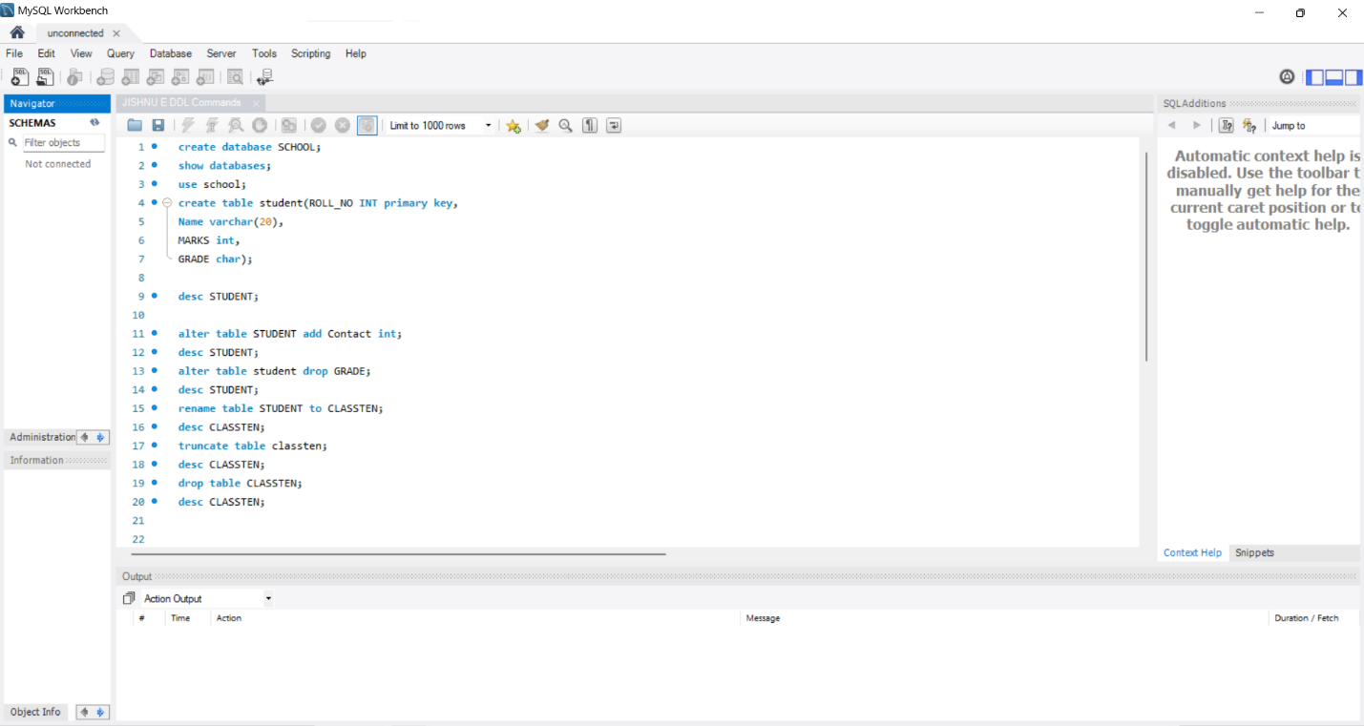

create database SCHOOL;

show databases;

use school;

create table student(ROLL_NO INT primary key,

Name varchar(20),

MARKS int,

GRADE char);

desc STUDENT;

alter table STUDENT add Contact int;

desc STUDENT;